Software Design Document (SDD)

This Software Design Document (SDD) serves as the blueprint for the FairMeet Project, guiding the analysis, planning, implementation, and decision-making processes throughout development. It provides a comprehensive overview of the system’s architecture, including both high-level, external-facing components, such as the application’s REST API, and detailed, internal design elements like classes and methods. Using Figma, a collaborative interface design tool, we outline the system’s graphical user interface (GUI) design, application programming interface (API) design, overall software architecture, and database and class structures. Additionally, we define updated roles and responsibilities for each team member to ensure our clear collaboration and accountability throughout the project lifecycle.

User Interface (GUI) Design :
1.1 Use Case Diagram:
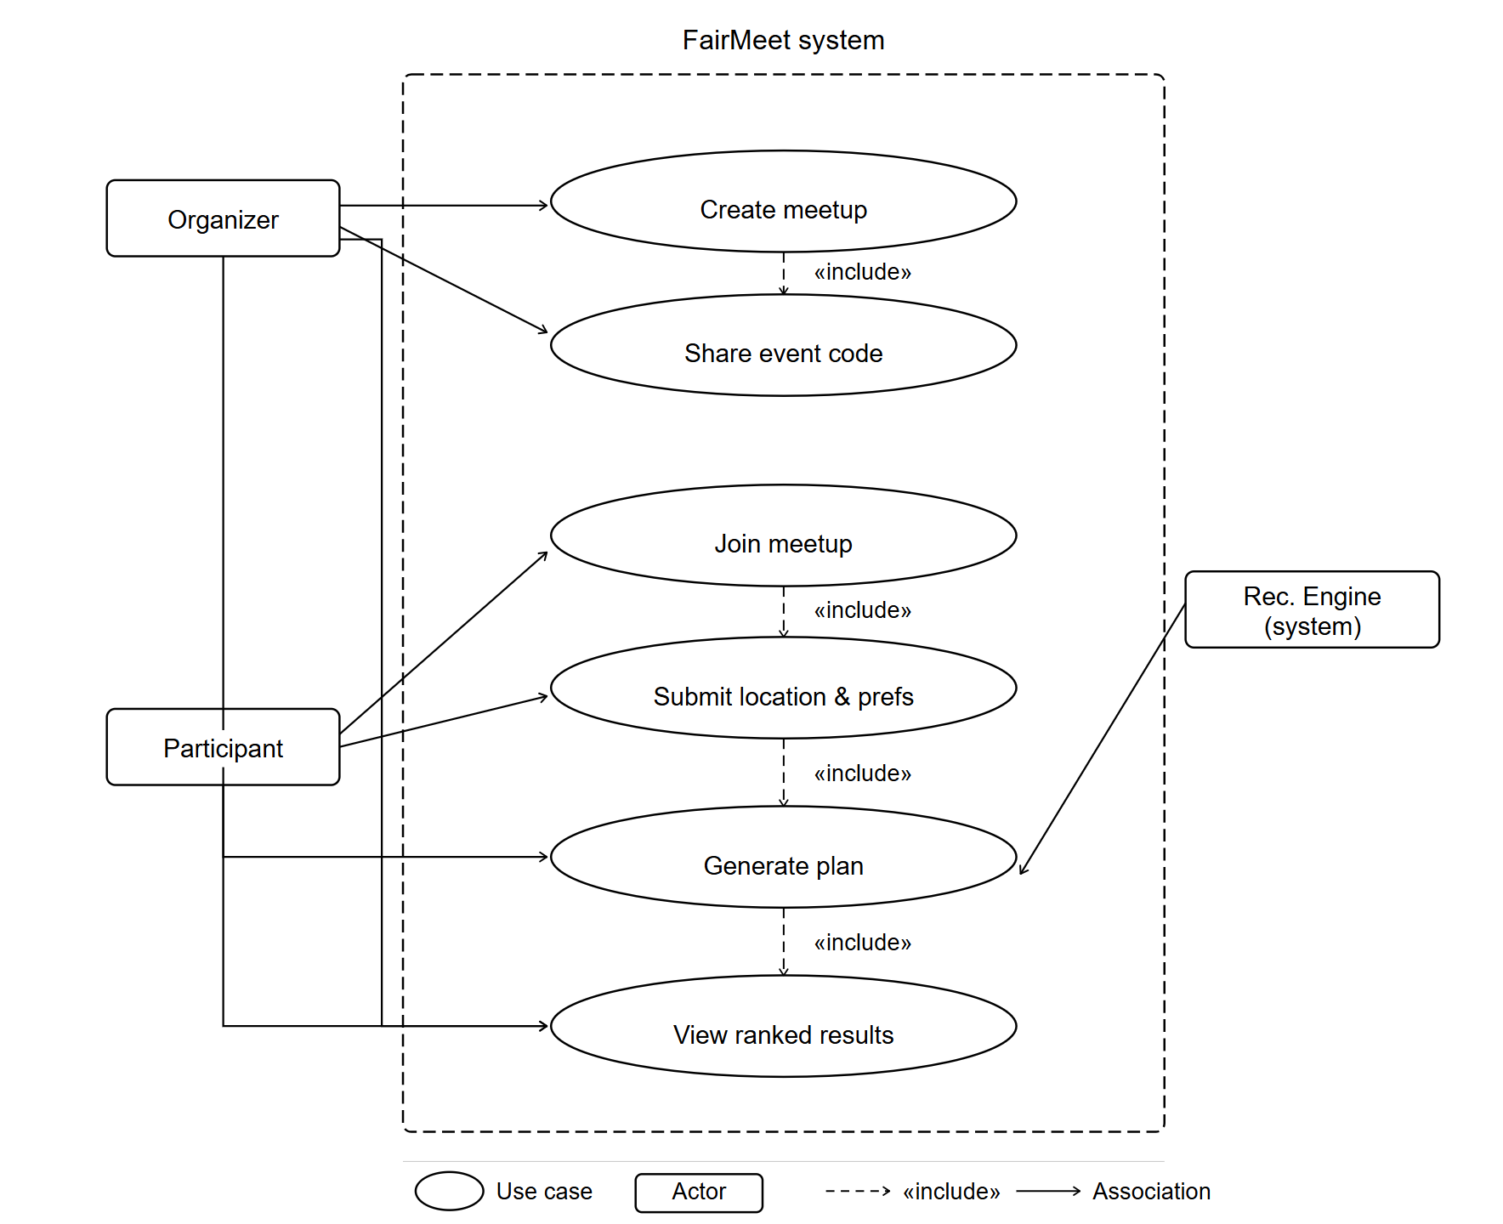
Figure 1. Use Case Diagram
Figure 1 illustrates the use case diagram of the FairMeet system. Three actors interact with the system: the Organizer, who initiates the meetup planning process; the Participant, who joins an existing session; and the Recommendation Engine, a system actor responsible for computing venue suggestions. The Organizer can create a meetup, share the generated event code, trigger the plan generation, and view the ranked results. The Participant can join a meetup using an existing code, submit their location and preferences, and view the results. The include relationships indicate mandatory dependencies between use cases: creating a meetup always includes sharing the event code, joining always includes submitting location and preferences, submitting location triggers plan generation, and plan generation always produces a ranked result set.
1.2 Activity Diagram:
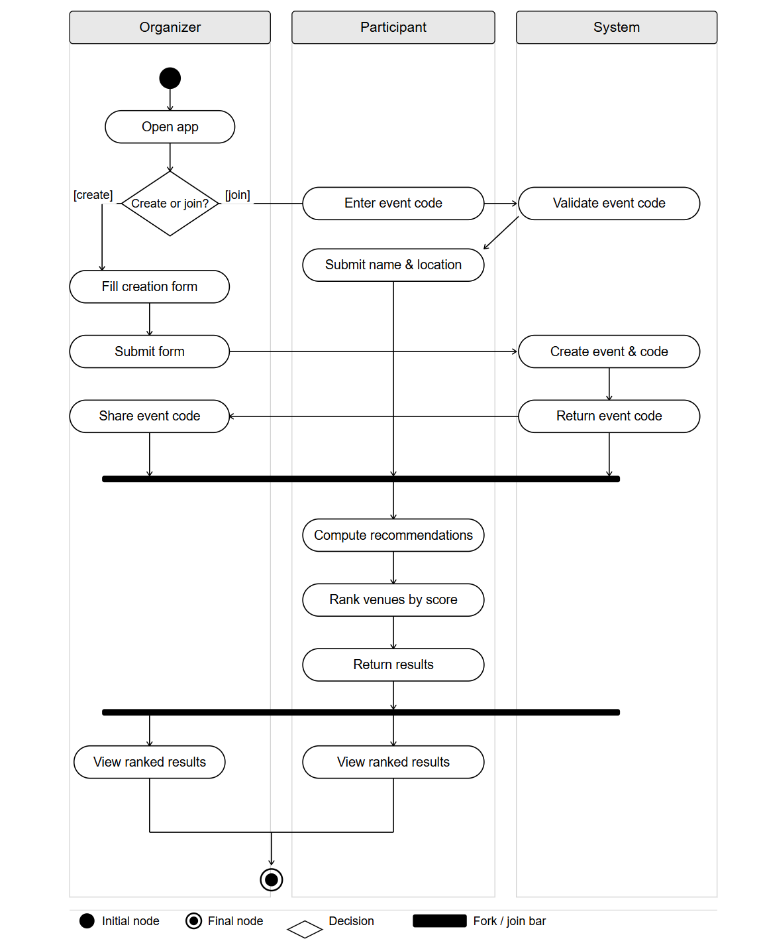
Figure 2. Activity Diagram
Figure 2 presents the activity diagram of the FairMeet user flow, organized into three swimlanes: Organizer, Participant, and System. The flow begins when a user opens the application and decides whether to create or join a meetup. On the create path, the Organizer fills and submits the creation form; the System then generates a unique event code and returns it, after which the Organizer shares it with participants. On the join path, the Participant enters the existing event code, which the System validates, before the Participant submits their name and location. A fork bar synchronizes both paths, ensuring that the System only proceeds to compute recommendations once all inputs have been collected. The System then ranks venues by fairness score and returns the results. A second fork bar distributes the results to both the Organizer and all Participants, who each land on the ranked results view.

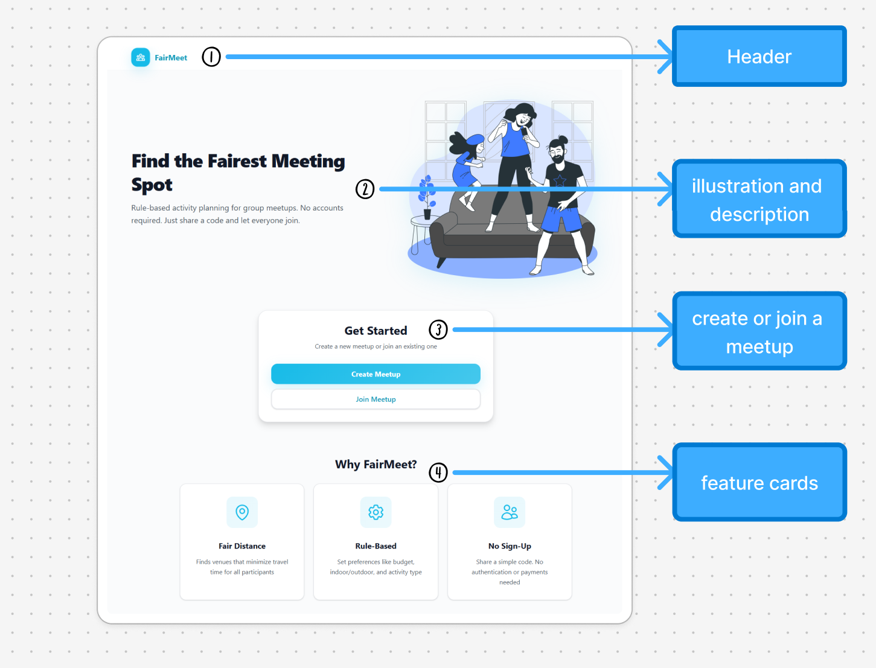
1.3 UI Design Implementation:

Figure 3. Landing Page

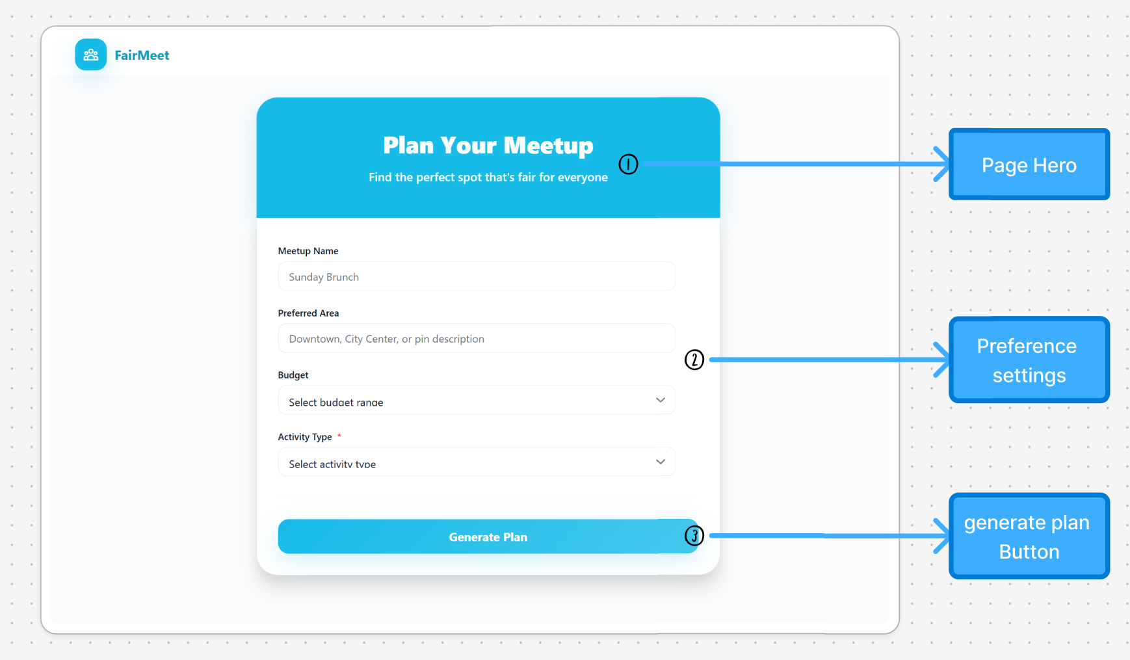

Figure 4. Create Meetup page

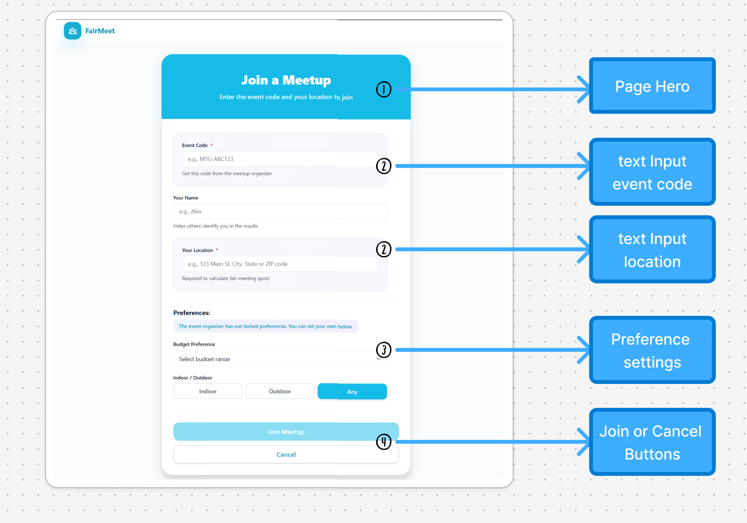

Figure 5. Join Meetup page

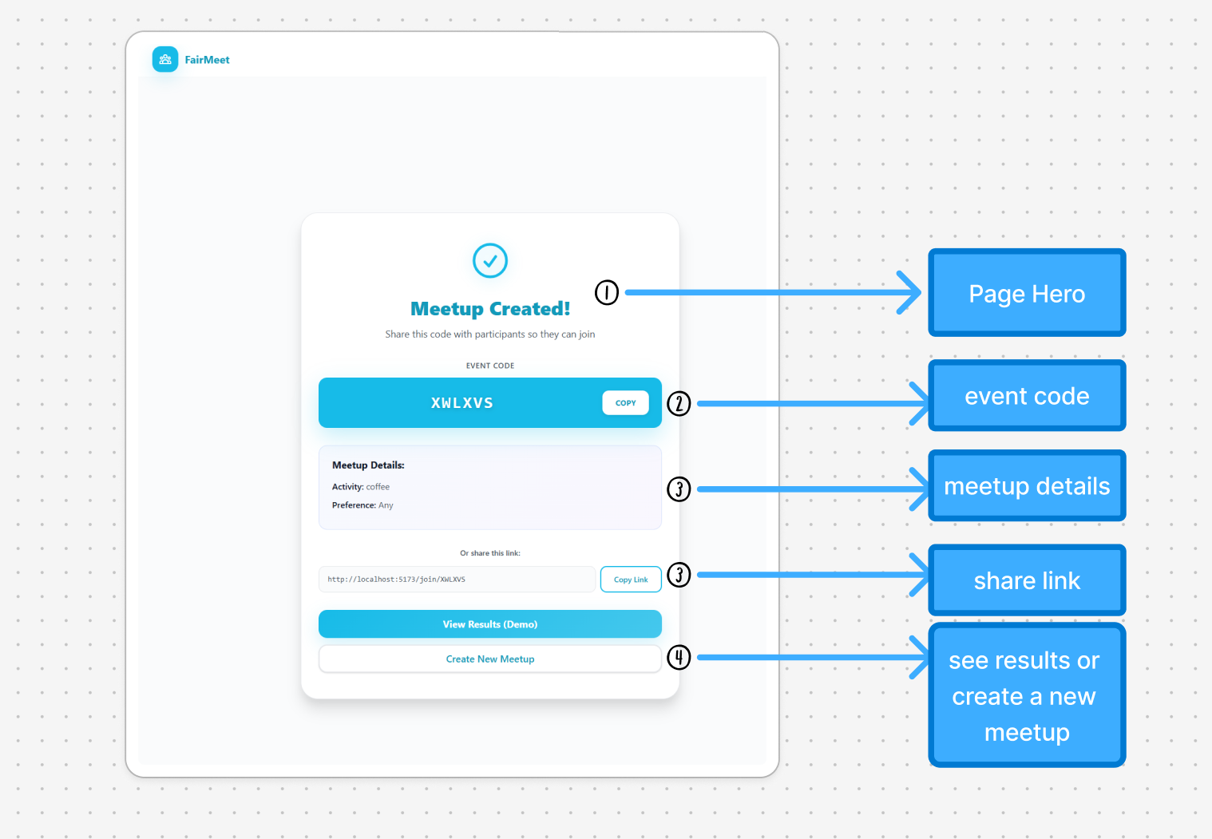

Figure 6. Event Created page
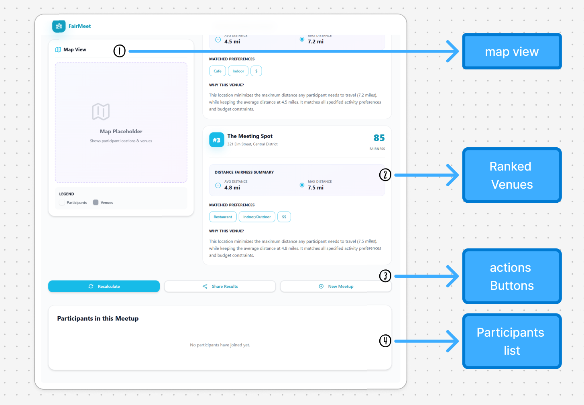

Figure 7. Results page
The FairMeet frontend is built with React and Vite, organized around a component-based architecture. The application relies on a set of reusable components — Header, Button, Input, Select, Card, and ToggleButton — that are composed differently across each page to maintain visual consistency while adapting to each page's specific function. Routing is handled by React Router, which maps each URL to its corresponding page component: Landing, CreateMeetup, JoinMeetup, EventCreated, and Results. Page-specific components such as VenueCard and ParticipantCard are scoped to the Results page and encapsulate the display logic for recommendation output. The following annotated screenshots illustrate the actual implementation of each page and its key UI components.
The FairMeet user interface is designed around a clear and intuitive two-stage interaction model: plan creation and result exploration. The goal is to minimize user effort while maximizing clarity in decision-making. On the plan creation page, users are presented with a structured input form that captures essential constraints such as meetup name, preferred area, budget, and activity type. The design intentionally favors dropdown menus and guided inputs over free-text fields to reduce ambiguity and ensure consistency in backend processing.
Once the user submits the form via the “Generate Plan” button, the system transitions to the results page. This page adopts a dual-pane layout, where a map is used to provide spatial awareness and a ranked list of recommended venues is displayed alongside it. Each venue card includes key decision metrics such as a recommendation score, average and maximum travel distances, and matched preferences. This layout supports both visual exploration and analytical comparison, allowing users to quickly converge on a suitable meeting location.
The overall user experience follows a linear yet responsive flow: input constraints, trigger computation, and interpret results. This simplicity is critical to ensuring accessibility for general users while still supporting more complex decision-making scenarios involving multiple participants.

Application Interface (API) Design
The FairMeet system exposes a small set of RESTful APIs that support the main workflow of the application, including meetup creation, participant joining, recommendation generation, and result retrieval. These APIs act as the communication layer between the React frontend and the backend service. Their design follows the overall architecture of the system, where the frontend sends HTTP requests, the backend coordinates meetup management and participant data, the recommendation engine performs the ranking logic, and the database stores persistent session and result information. The APIs are designed to be simple, stateless, and easy to extend as the project grows.
At the beginning of the workflow, the frontend uses the POST /api/create endpoint to create a new meetup session. This endpoint receives the organizer’s initial meetup information, such as meetup title, preferred activity type, budget range, and other basic planning constraints. After the request is processed, the backend creates a new meetup record, generates a unique event code, and returns that code to the frontend so it can be shared with other participants. This endpoint supports the organizer’s role in the use case and activity diagrams, where creating a meetup leads directly to generating and sharing the event code. In the implemented interface, this also aligns with the Event Created page, which displays both the event code and the share link.
After a meetup has been created, additional users can enter the session through the POST /api/join endpoint. This endpoint accepts the meetup code together with participant-specific input, such as participant name, location, and preference selections. The backend validates the meetup code, associates the participant with the correct meetup session, and stores the submitted data for later recommendation processing. This endpoint is important because the FairMeet workflow depends on collecting information from multiple participants before the system computes a fair meeting location. It directly reflects the Participant actions shown in the diagrams, especially joining a meetup and submitting location and preferences.
Once enough participant information has been collected, the frontend triggers recommendation generation through the POST /api/plan endpoint. This is the main computational endpoint of the system. It receives the relevant meetup identifier or event code and passes the session data to the backend service layer. The backend then gathers the stored participant inputs and venue data, invokes the recommendation engine, and computes ranked venue suggestions based on fairness and preference matching. The resulting recommendations include information such as venue ranking, recommendation score, and travel distance metrics. This endpoint is consistent with the sequence abstraction in the SDD, where the frontend submits form data, the backend invokes the recommendation engine, and the ranked results are returned and stored.
To support result viewing after computation, the system provides the GET /api/result endpoint. This endpoint allows the frontend to retrieve previously generated recommendation results for a given meetup session. The backend reads the stored recommendation result from the database and returns a structured JSON response containing the ranked venues and their associated metrics. This separation between plan generation and result retrieval improves modularity because the recommendation process does not need to be rerun every time the user refreshes the results page. It also matches the class and database design, where recommendation results are represented and stored separately from the meetup and participant input data.
The API design follows standard HTTP and REST conventions. State-changing operations such as creating a meetup, joining a meetup, and generating a plan use POST requests, while result retrieval uses GET. JSON is used as the request and response format because it integrates naturally with the React frontend and backend services. In development, a proxy layer such as the Vite development proxy can forward frontend API calls to the backend server and avoid cross-origin issues. In deployment, the same routing role can be handled by a reverse proxy such as Nginx. This design keeps the frontend and backend loosely coupled and supports a cleaner development workflow.
In all, the API design is aligned with the project’s use cases, activity flow, class design, and database structure. The endpoints map naturally to the major backend service actions such as createMeetup(), joinMeetup(), generatePlan(), and fetchResults(), while also supporting the user-facing workflow shown in the interface design. By keeping the API surface small and focused on the main planning cycle, the system remains understandable for the current project scope while leaving room for future extensions, such as updating preferences, regenerating plans, or retrieving meetup session details.
Core API Endpoints
- POST /api/create: creates a new meetup session and returns a unique event code
- POST /api/join: allows a participant to join an existing meetup by submitting the event code, location, and preferences
- POST /api/plan: triggers the recommendation engine and generates ranked venue suggestions
- GET /api/result: retrieves the stored recommendation results for display on the results page

Software Architecture Design

3.1 High-Level Architecture:

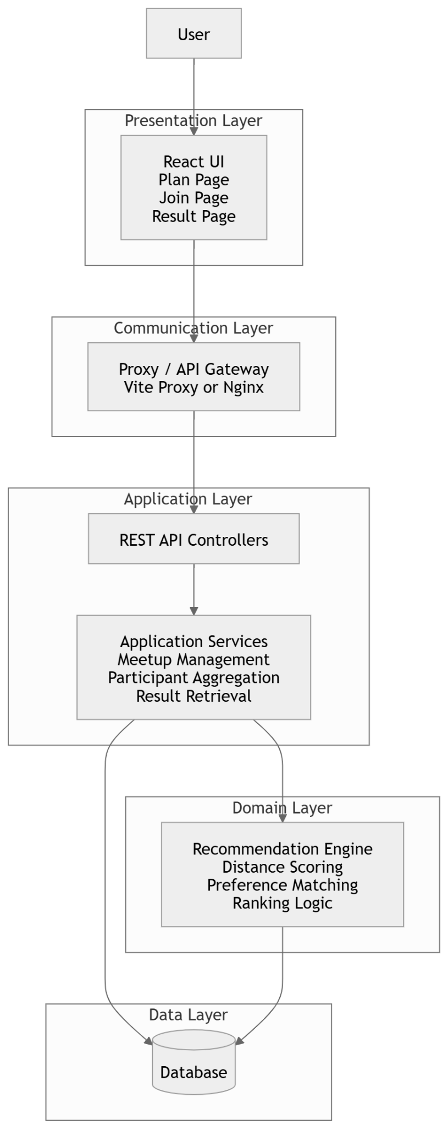
Figure 8. High level architecture Diagram

The FairMeet system adopts a layered architecture that separates concerns across the frontend, backend, recommendation engine, and data storage components. At the top layer, the frontend is implemented using React, responsible for rendering the user interface and handling user interactions. It communicates with the backend via HTTP requests, abstracting the underlying logic from the user.
Between the frontend and backend, a proxy layer is employed to manage routing and environment configuration. This layer ensures that API requests are correctly forwarded and helps to isolate the frontend from backend implementation details.
The backend server acts as the central coordinator of the system. It handles incoming API requests, manages meetup sessions, aggregates participant data, and invokes the recommendation engine. The recommendation engine is the core computational component of the system, responsible for generating ranked venue suggestions. It employs techniques such as geometric median calculations, weighted scoring based on distance and preferences, and multi-objective optimization.
The database layer stores persistent data such as meetup sessions, participant information, venue details, and computed results. The overall architecture is designed to be scalable, with stateless backend services for horizontal scaling.

3.2 Sequence Abstraction:

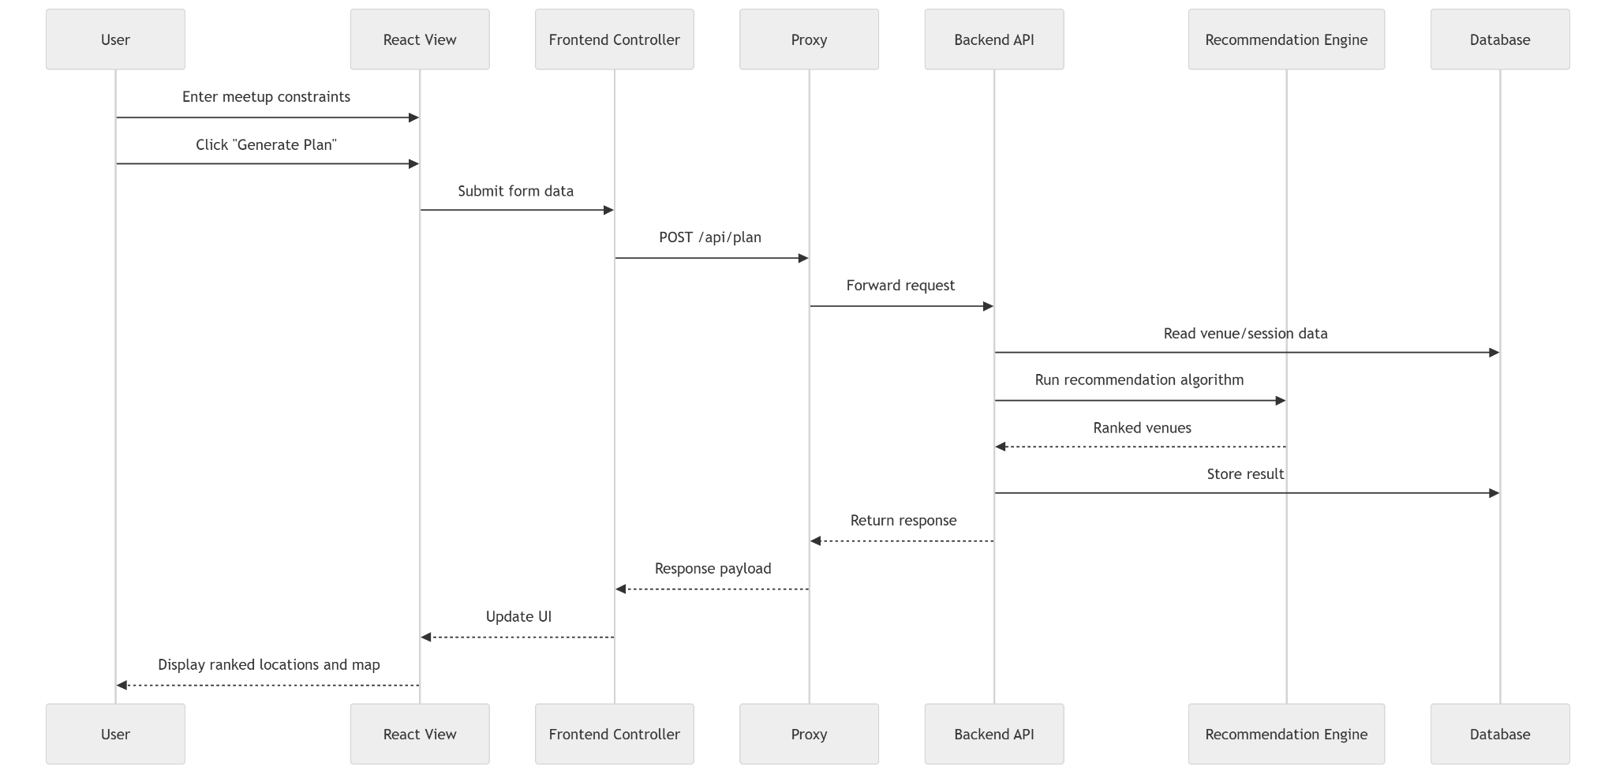

Figure 9. Sequence Abstraction Diagram

The interaction begins when the user enters meetup constraints through the FairMeet interface. These constraints include participant locations, preferred activity type, and budget range. Once the user clicks the “Generate Plan” button, the frontend view captures the input data and forwards it to the controller layer within the React application. Here we capture the structural flow in a more general way, aggregating creating meetup, joining meetup procedures.
The frontend controller is responsible for preparing and dispatching an API request. It sends a POST request to /api/plan through the proxy layer. The proxy acts as an intermediary, forwarding the request to the backend server while abstracting away environment-specific configurations such as port numbers or domain differences.
Upon receiving the request, the backend API controller parses the input data and begins processing the meetup plan. It first interacts with the database to retrieve relevant information, such as available venues or previously stored session data if applicable. After gathering the necessary data, the backend invokes the recommendation engine, which serves as the core computational component of the system.
The recommendation engine processes the input by evaluating candidate venues based on multiple criteria. These include distance calculations (e.g., minimizing average or maximum travel distance among participants), preference matching (e.g., activity type and budget), and overall scoring. The engine then produces a ranked list of suitable venues.
Once the recommendation results are generated, they are returned to the backend controller. The backend stores these results in the database for future retrieval or caching purposes. It then constructs a response containing the ranked venues and associated metrics, and sends this response back through the proxy layer to the frontend.
The frontend controller receives the response and updates the application state accordingly. The view layer then re-renders the interface, displaying the recommended venues in a structured format alongside a map visualization. This allows the user to compare options and make an informed decision.

Database and Class Design
The database design for FairMeet focuses on capturing the relationships between meetups, participants, venues, and recommendation results. Each meetup is uniquely identified and serves as a container for multiple participants. Participants contribute their location and preferences, which are used as inputs to the recommendation process. Venues are stored with attributes such as location, category, and price level, forming the candidate pool for recommendations.
The results of the recommendation process are stored separately, linking meetups to ranked venues along with associated metrics such as scores and travel distances. This separation allows results to be recomputed or updated without modifying the underlying meetup or participant data.
From an object-oriented perspective, the system can be modeled using classes such as Meetup, Participant, Venue, and RecommendationEngine. The RecommendationEngine encapsulates the core logic for computing scores and ranking venues, promoting modularity and ease of extension. Relationships between entities are maintained through identifiers, ensuring a clean separation between data representation and business logic.

Class Design:

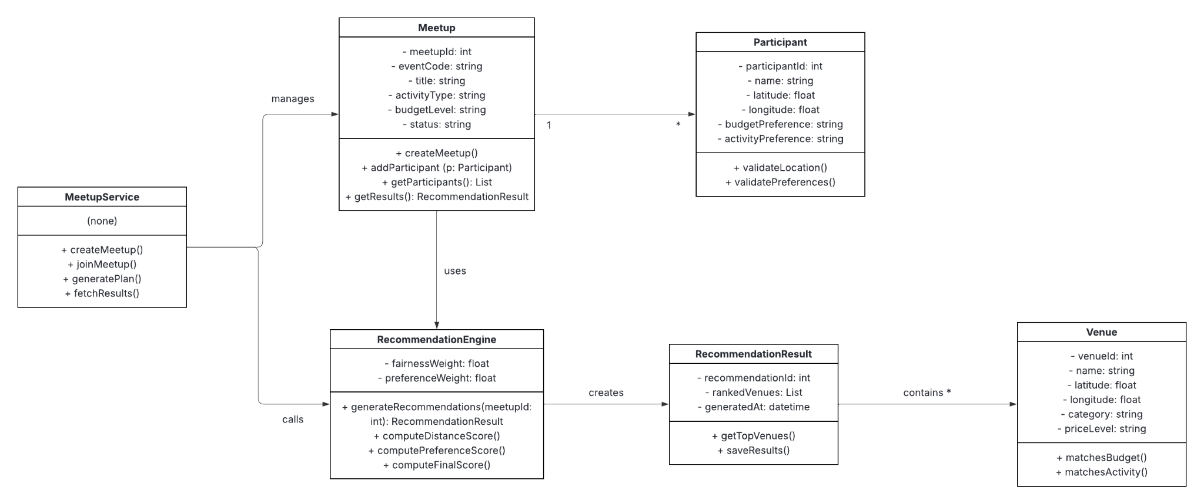
Figure 10. Class Diagram
The class design in figure 10 is organized around a small set of core classes that reflect the main concepts of the system while also separating user data, recommendation logic, and workflow control. This design follows object-oriented principles by assigning each class a focused responsibility. As a result, the system becomes easier to understand, maintain, test, and extend. Rather than placing all logic inside one large backend module, the design divides responsibilities across domain classes such as Meetup, Participant, and Venue, computational classes such as RecommendationEngine, result-handling classes such as RecommendationResult, and coordination classes such as MeetupService.
At the center of the design is the Meetup class. This class represents a single meetup-planning session and acts as the main container for the information associated with that session. It stores the identity and state of the meetup, including values such as the meetup ID, event code, title, selected activity type, budget level, and current status. The reason this class is central is that nearly every other class in the system relates back to a particular meetup. A meetup may begin in a newly created state, then progress as participants join and submit their information, and finally move into a state where recommendations have been generated and results can be viewed. The Meetup class therefore represents the lifecycle of a planning session. Its methods, such as createMeetup(), addParticipant(), getParticipants(), and getResults(), reflect the fact that it is responsible for managing the session’s own data and its immediate relationships. In design terms, Meetup is the parent domain object around which the planning process is built.
The Participant class represents an individual user who joins a meetup and provides input to the recommendation process. Each participant belongs to exactly one meetup and contributes personal data that the system uses for decision-making. This includes the participant’s name, geographic coordinates, and planning preferences such as budget or activity type. The main purpose of this class is to encapsulate user-specific input in a structured way so that it can be validated and later consumed by the recommendation logic. Methods such as validateLocation() and validatePreferences() show that the participant object is not just passive storage, but also carries responsibility for ensuring that its own data is acceptable before being used in calculations. This improves design quality because validation can happen close to the data itself instead of being scattered across unrelated parts of the codebase. In practice, the Participant class is essential because the entire fairness model depends on accurate participant locations and preference data.
The Venue class represents one candidate location that may be recommended for the group meetup. This class stores descriptive and geographic information about a venue, including its ID, name, coordinates, category, and price level. Its role in the system is to provide the pool of possible meeting options that the recommendation engine can evaluate. Because venues are treated as reusable objects rather than temporary values, they can be loaded from a database or dataset, filtered, scored, and reused across many meetup sessions. The methods matchesBudget() and matchesActivity() suggest that a venue can evaluate whether it satisfies specific user constraints. This is useful because it keeps venue-related filtering logic attached to the venue model itself. From a design standpoint, the Venue class is a clean abstraction of the real-world place being recommended. It allows the system to reason about locations in a consistent and modular way.
The RecommendationEngine class is the most important computational component in the class design. While the other classes mainly represent data and domain entities, this class encapsulates the core algorithmic logic of FairMeet. Its purpose is to take participant inputs and candidate venues, apply the system’s fairness and preference rules, compute scores, and produce a ranked set of recommendations. This separation is extremely important because the recommendation process is the main value of the application, and it should remain isolated from user interface code, routing code, and raw data models. In your design, the RecommendationEngine has attributes such as fairness weight and preference weight, which suggests that the system may adjust how strongly it prioritizes travel fairness versus preference matching. Its methods, including generateRecommendations(), computeDistanceScore(), computePreferenceScore(), and computeFinalScore(), show a clear step-by-step decomposition of the ranking process. This class design breaks a complex operation into smaller logical units. It also makes the algorithm easier to test and modify later. For example, if the team later wants to incorporate additional criteria such as venue rating, accessibility, or indoor versus outdoor preference, that enhancement can be made inside the recommendation engine without forcing major changes to the rest of the system.
The RecommendationResult class represents the output of the recommendation process. Once the recommendation engine finishes computing candidate scores and rankings, those outputs need to be packaged into a structured result object that can be stored, retrieved, and displayed. That is the purpose of this class. It contains information such as the recommendation ID, generated timestamp, and the list of ranked venues. Its methods, such as getTopVenues() and saveResults(), indicate that this class is responsible for organizing and exposing the results in a useful form. This improves the overall design because it separates the act of computing recommendations from the act of storing or presenting them. The recommendation engine produces the results, but the RecommendationResult class represents them as a stable object that the rest of the system can work with. This makes the output easier to pass between backend layers, save in the database, or return through the API.
The MeetupService class functions as the coordination layer of the backend design. While domain classes such as Meetup, Participant, and Venue represent the entities of the system, and the RecommendationEngine performs the calculations, there still needs to be a class responsible for orchestrating the full workflow. That is the role of the service layer. MeetupService receives requests from the API layer and coordinates the required actions across the other classes. For example, when a user creates a meetup, joins one, requests plan generation, or retrieves results, the service class acts as the controller of those higher-level processes. Methods such as createMeetup(), joinMeetup(), generatePlan(), and fetchResults() reflect this coordinating role. This approach prevents the domain classes from becoming overloaded with workflow logic and keeps the recommendation engine focused only on scoring and ranking. In other words, MeetupService handles application flow, while the domain classes handle state and behavior specific to themselves.
The relationships between these classes are also important to the design. A Meetup has many Participant objects because one meetup session can include multiple people. A Meetup is also associated with recommendation generation, because the planning request belongs to a specific session. The RecommendationEngine uses the data stored in Meetup and its related participants to evaluate available Venue objects. It then creates a RecommendationResult, which contains the ranked venues generated for that meetup. MeetupService interacts with Meetup and RecommendationEngine to coordinate these steps. These relationships reflect the real behavior of the application and make the class design intuitive. Someone reading the diagram can understand not only what objects exist, but also how they collaborate during execution.
From a design-quality perspective, one of the strengths of this class structure is separation of concerns. Each class has a distinct job. The Meetup class represents a planning session. The Participant class represents user input. The Venue class represents candidate destinations. The RecommendationEngine performs computations. The RecommendationResult packages the output. The MeetupService coordinates the overall use cases. This separation is valuable because it reduces coupling and improves maintainability. If the team needs to change the venue scoring formula, the changes mainly affect the recommendation engine. If the team wants to store more participant details, that primarily affects the participant model. If the workflow of creating or joining a meetup changes, the service layer can be adjusted without rewriting the core ranking logic.
Another important strength is extensibility. The current class design is simple enough for the current scope of the project, but it leaves room for future growth. For example, the team could later add classes such as MapService, VenueRepository, or NotificationService without disrupting the current structure. The recommendation engine could be expanded with additional scoring functions, and the service layer could support more complex planning workflows such as editing participant preferences or regenerating plans with different weights. Because the main responsibilities are already cleanly separated, these future additions would fit naturally into the design.
The class design also supports testability. Since the recommendation engine is isolated as its own class, it can be tested independently with sample meetups, participants, and venues. The Participant class can be tested for validation logic. The MeetupService can be tested for proper orchestration of meetup creation, participant joining, and plan generation. This is much better than having all the logic embedded directly in one route handler or one monolithic script. In a team project, that matters because it allows different members to work on different classes and verify their correctness separately.
Database Design:
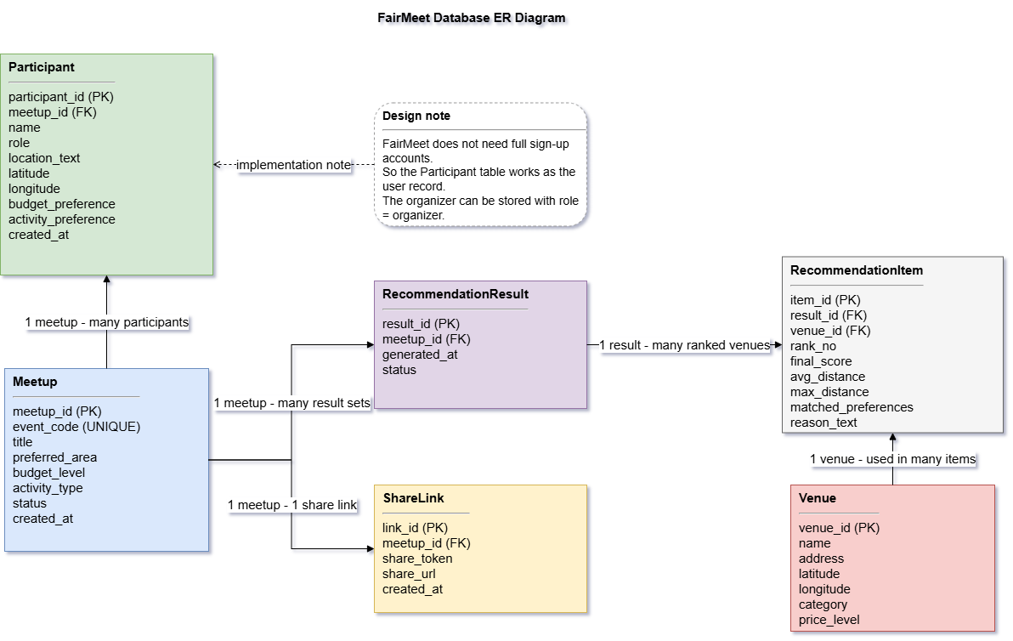

Figure 11. Database ER Diagram
The database design of FairMeet is organized around a small set of core entities that reflect the main data needs of the system. Similar to the class design, the database structure is centered on the meetup-planning workflow and is intended to keep user input, venue data, and recommendation results clearly separated. This design supports the main project functions, including creating a meetup, allowing participants to join through an event code or shared link, storing location and preference information, and saving the ranked recommendation results generated by the system. By separating these responsibilities across multiple related tables, the database becomes easier to understand, maintain, and extend as the project develops.
At the center of the database design is the Meetup table. This table represents a single meetup-planning session and serves as the main parent entity for the rest of the data. It stores the basic information of each meetup, such as meetup ID, event code, title, selected activity type, budget level, organizer-related information, and current status. This table is important because most other records in the system are connected back to a specific meetup. In this sense, the Meetup table plays a similar role to the Meetup class in the class diagram, since it represents the lifecycle of one planning session from creation to recommendation generation.
The Participant table stores the users who join a meetup and provide input to the recommendation process. Each participant belongs to one meetup and contributes data such as name, location, and planning preferences. This information is essential because the recommendation logic depends on participant coordinates and preference selections in order to calculate fairness and compatibility. Storing participant data separately from meetup data improves organization and allows multiple participants to be associated with the same meetup session in a clean relational structure.
The Venue table stores candidate meetup locations that can be evaluated by the system. Each venue includes descriptive and geographic information, such as venue ID, name, coordinates, category, address, and price level. These venues form the candidate pool used during recommendation generation. Because venue data is stored independently, the same set of venues can be reused across different meetup sessions, which makes the design more efficient and consistent. This also matches the role of the Venue class in the class design, where venues are treated as reusable objects that can be filtered, scored, and ranked.
The RecommendationResult table and its related result details are used to store the output of the recommendation process. After participant data and meetup constraints are processed, the system generates ranked venue suggestions along with associated metrics such as scores and travel distances. These results are stored separately from the original meetup and participant data so that recommendations can be updated or recomputed without changing the underlying input records. This separation is important because it keeps input data and generated output logically distinct, which improves both clarity and maintainability in the database design.
In addition, the database may include supporting structures such as a ShareLink table or a recommendation item table to better support practical system functions. For example, a share link or event code is needed for participants to access and join a meetup, while ranked result items allow the system to store multiple recommended venues under one generated result. These additions are reasonable at the database level even if they are not emphasized as separate major classes in the class diagram, because database design focuses on persistent storage and relational structure rather than only object-oriented modeling.
Overall, the FairMeet database design is consistent with the class design in terms of its main concepts and system workflow. Both designs are centered on Meetup, Participant, Venue, and RecommendationResult as the main entities of the application. However, not every class in the class diagram is directly translated into a database table. Classes such as RecommendationEngine and MeetupService belong to the application logic layer and are responsible for computation and coordination rather than persistent storage. Therefore, the database design remains aligned with the class design while being adapted to the practical needs of PostgreSQL implementation.

Updated Roles & Responsibilities
Since the submission of our last project artifact, the SPMP Document, we can provide updates on the individual contributions of each team member, which are provided by the team member in reference.
Vincent Liu keeps working on the project manager role. As for recent work, he led the discussion of the system architecture, interface design, api design and class design. The requirements and expectations of the design work are communicated thoroughly to team members. Besides, he has started the code of this stage as well as actively managing the github repository and branches.
Olivia Freund was originally designated the primary contributor for both testing and documentation for the team. Although formal testing has not yet been required, she is actively strengthening her understanding of Git commands and tools to ensure readiness when the project reaches the testing phase. She plans to begin testing after the Midterm Examination. In addition, Olivia also organizes and develops outlines for any necessary documents, helping maintain clarity and structure throughout the documentation process, as well as formats the document to meet academic and professional standards.
Amar was responsible for the graphical user interface design section of the Software Design Document. He produced the UML Use Case diagram, which models the interactions between the two user roles “Organizer and Participant” and the system actors, documenting the full set of actions each actor can perform within the application. He also produced the UML Activity diagram, which details the sequential user flow across the three swimlanes “Organizer, Participant, and System” from opening the application to viewing the ranked results. In addition, he provided annotated screenshots of each page of the application, documenting the layout structure and key UI components of the interface.
Pouria researched various open source datasets and APIs that could be used in the backend for the recommendation system. He mostly focused on location data for the greater Boston area, and identified various open source datasets that included restaurants, cafes, parks, etc. After the latest meeting, the team decided to focus on using a location API similar to the APIs that are offered by Google.
Muhua was responsible for the database design section of the Software Design Document. He designed the database schema for FairMeet and created the database diagram to model the relationships among meetups, participants, venues, shared access information, and recommendation results. His work helped make sure that the database supports the main project functions such as meetup creation, participant joining, storing preferences and locations, and saving ranked venue results. In addition, he contributed to the API design section by refining the descriptions of the main endpoints and making them more consistent with the system workflow, backend architecture, and PostgreSQL-based storage design.
Conclusion
In conclusion, this Software Design Document outlines a clear and structured blueprint for the FairMeet system, establishing a strong foundation for development and collaboration. By defining the system’s user interface, API design, architecture, and data models, the document ensures alignment across all components and team members. The layered architecture and modular design promote scalability, maintainability, and flexibility, while the integration of the recommendation engine enables efficient and fair decision-making for group meetups. Additionally, the well-defined roles and responsibilities support effective teamwork and accountability throughout the project lifecycle. Overall, this SDD serves as a comprehensive guide that will drive the successful implementation, testing, and future evolution of the FairMeet application.

